SDGs Implementation Review

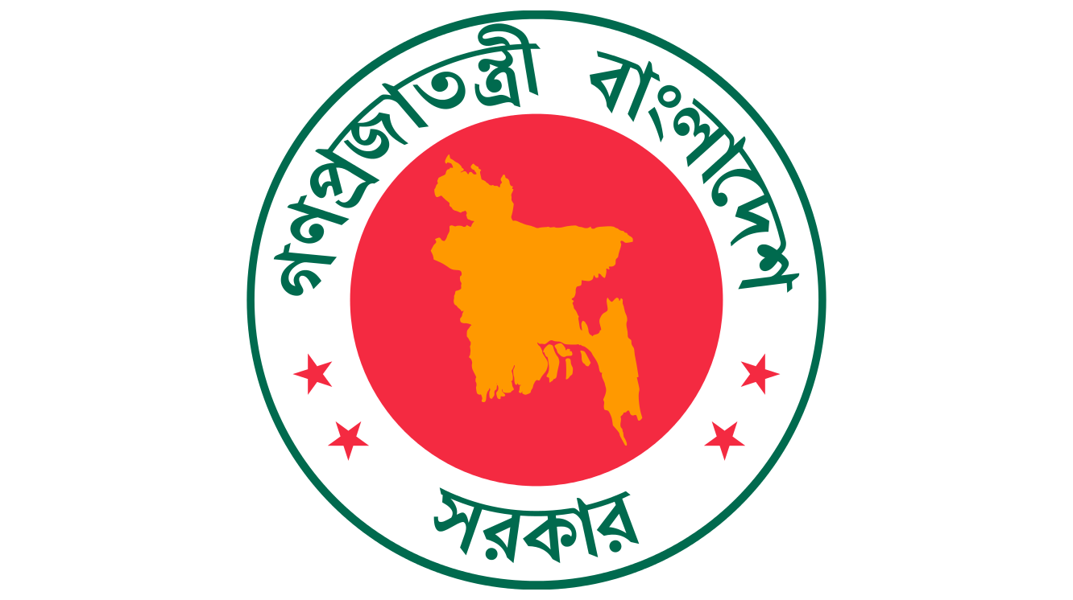

Government of People’s Republic of Bangladesh
Cabinet Division
SDGs Implementation Branch
June’2018

Preface

Cabinet Division is mainly responsible for achieving the Targets of 1.1,1.2,1.3,1.4 of Goal 1 (End Poverty) and Targets of 16.5,16.6 of Goal 16 (Peace, Justice and Strong Institutions) of SDGs (Sustainable Development Goals). This division mostly plays the coordination and supervisory role in attaining those targets. After having several workshops and inter-ministerial meetings Cabinet Division has managed to formulate the combined work plans against 3 Targets out of its mandated 6 targets as lead. Besides these, direct activities against those targets are also in full swing to achieve the SDGs. Actions like National Integrity Strategy (NIS), Annual Performance Agreements (APA), Grievance Redress System (GRS), Right to Information (RTI), Innovation in Public Service Delivery are directly influencing the Targets 16.5 and 16.6. On the other hand implementation of National Social Security Strategy (NSSS) has already put some significant impact on poverty reduction.

Executive Summary

Poverty reduction through Social Protection (SDGs Target 1.3) has been highlighted in our 7th Five year plan and SDGs financial needs assessment. Government current yearly spending in social protection programs is 6.78 Billion US$ and an additional cost of 1.3-2.5 Billion US $ needs to be spent in each of the years till 2030 for eliminating extreme poverty. This additional amount needs to be met by increasing the spending on Social Security Programs. To arrange this huge amount through a long period of time is a big challenge.
To ensure governance in Social Protection system action plan to implement NSSS (National Social Security Strategy) has been approved. Cabinet Division has a plan to create a single registry MIS to overcome the general loop holes of the whole social protection system.
Regarding the targets 16.5 and 16.6 regular activities like APA, NIS, RTI, GRS, Citizen’s Charter, Innovation in Public Service are being carried out. To make these activities more effective a few initiatives have been taken, i.e. inspiring the Ministries to undertake more challenging targets, forming integrated GRS and formulating the third generation Citizen’s Charter and encouraging innovation in public service. Besides these, a number of projects are in the pipeline to make APA and NIS functions more outcome oriented. For ensuring inclusive policy making a project titled P4D (Platform for Dialogue) is expected to be launched in 2018.
Non availability of baseline data for 6 indicators out of 10 is one of the major challenges in achieving the targets. To develop an M & E framework baseline data is indispensable. Therefore, immediate efforts should be taken to generate relevant baseline data. Lack of people’s awareness on governance tools and at absence of private sector involvement in formulation SDGs work plan should be addressed for successful implementation of SDGs.

Introduction:
Cabinet Division (CD) facilitates other ministries in formulation of Acts, Policies & Strategies; assists the Cabinet in making policies; monitors the Implementation of Cabinet Decisions; Coordinates the activities of Ministries/Divisions; supervises the Field administration; ensures reforms with a vision to Build a ‘Sonar Bangla’ by establishing governance in every sphere of public service. As per Allocation of Business and SDGs mapping, Cabinet Division is mainly liable for achieving the Targets of 1.1,1.2,1.3,1.4 of Goal 1 (End Poverty) and Targets of 16.5,16.6 of Goal 16 (Peace, Justice and Strong Institutions) of SDGs (Sustainable Development Goals) as Lead. In attaining those targets this division mostly has to play the coordination and supervisory role. Scope of CD against targets of 1.1,1.2,1.3,1.4 of Goal 1 (End Poverty) is generally related to coordination where as against targets of 16.5,16.6 of Goal 16 (Peace, Justice and Strong Institutions) it is both coordination and actions for implementation.
Methodology:
CD has arranged 6 workshops and several inter-ministerial meetings to formulate an integrated work plan against specific targets. All the associate ministries actively participated in those workshops and meetings. Following those, all ministries/divisions and other organizations with exception of one or two, sent their action plan against individual targets. Record of the discussions in the workshops/meetings, SDGs document and summary of the work plans of the CD and associates have been used in this SDGs implementation review. The output from non-government sector and academia, is absent in this review as they were not invited in the initial SDGs implementation activities,.
Progress:
Cabinet Division (CD) has to work together with 33 and 13 Ministry/Divisions and other organizations as associates to achieve the targets of 1.1-1.4 and 16.5-16.6 respectively. Therefore, without integrated, coordinated and combined work efforts, attainment of SDGs will be a far cry. Keeping it in view, Cabinet Division has pressed more emphasis on formulation of separate integrated work plan against individual targets. To incorporate the activities and ideas against different targets, CD asked all the associates to submit their work plans and arranged workshops accordingly for these purposes. After rigorous discussions, reviews, debates and corrections CD has managed to formulate the combined draft work plans against 3 targets (1.3,16.5,16.6) out of 6.
Besides planning for the implementation of SDGs, CD is performing its regular activities aiming at mandated targets especially in the area of governance. Now we have very significant outputs from different ministries/divisions and their subordinate offices in terms of APA and annual work plans of NIS. The successful formation of the third generation Citizen’s Charter (CC) will ensure better quality of public service as well as enhance transparency. An integrated Grievance Redress System (GRS) is in the pipeline which will be instrumental in establishing accountability in government offices. Innovation in public service has been encouraging to simplify the service delivery process for the betterment of citizen welfare. For the guaranteed participation of ordinary citizens in policy making, a project namely, P4D (Platform for Dialogue) is going to be launched very soon. It has been a long aspiration to
incorporate grass roots level opinions in policy formulation to realize the more ‘Bottom-Up’ approach. The idea of ‘Leaving no one Behind’ can be partially materialized if P4D project can be implemented successfully. All those above mentioned efforts are specifically aimed at achieving SDGs targets 16.5 and 16.6.
Regarding the targets related with poverty reduction (1.1-1.4), combined work plan of target 1.3 (Social Protection) has been prepared in accordance with action plan of implementing NSSS as per recommendations from SDGs work shop. It is assumed that moderate poverty will be taken care of by economic development but for eliminating extreme poverty, spending on social protection needs to be increased.
Progress according to M & E Frame work: : Table-1:
Indicators | Baseline Data 2016 | Milestone for 2020 | Progress  (Up to June 2018) | Source  of  Data
1.1.1 Proportion of Population below International Poverty Line | 13.9% | 9.30% | Data is not available | WB
1.2.1 Proportion of Population below National Poverty Line | UPL: 24.3  LPL: 12.9% | UPL: 18.6%  LPL: 8.9% | Data is not available | BBS
1.2.2 Proportion of Population living in poverty in all its dimensions | Baseline Data is not Available, therefore Milestone cannot be set
1.3.1 Proportion of Population covered by Social Protection | 28.7% | 30% | Data is not available |  | BBS
1.4.1 Proportion of Population with Access to Basic Services | Baseline Data is not Available, therefore Milestone cannot be set
1.4.2 Adult Population with secure tenure rights to land | Baseline Data is not Available, therefore Milestone cannot be set
16.5.1: Proportion of Persons paid bribe to public official during last 12 months  12 months | Baseline Data is not Available, therefore Milestone cannot be set
16.5.2: Proportion of Businesses paid bribe to public official during last 12 months | Baseline Data is not Available, therefore Milestone cannot be set
16.6.1: Primary government expenditures as % of original budget | Baseline Data is not Available, therefore Milestone cannot be set
16.6.2: Population satisfied with public services | Baseline Data is not Available, therefore Milestone cannot be set
In table -1 above we can observe that latest data are not available as such progress cannot be shown against 4 indicators (1.1.1, 1.2.1,1.2.2,1.3.1) against these indicators. Baseline data are not available against other 6 indicators hence milestones cannot be set in current M&E framework.

Challenges:
Generate relevant base line data for 6 indicators stands as the main challenges in achieving SDGs for Cabinet Division. For this reason, for certain targets especially 1.4, 16.5 and 16.6, we do not know where we are right now and where to go. Unless and until this aspect is addressed, proper and effective work plan cannot be on the table. According to 7th five year plan and SDGs financial needs assessment study- additional amount of an additional cost of 1.3-2.5 Billion US $ needs to be spent in social protection programs in each of the years till 2030 with current yearly spending of 6.78 Billion US$. To arrange this huge fund for a longer period of time will be a big challenge. Moreover, addressing the general loopholes of social protection programs i.e. improper selection, ghost beneficiaries, leakage, overlapping is also a formidable challenge.
Regarding targets 16.5 and 16.6 the findings/recommendations from the workshops indicate that we need to make our governance tools i.e. APA, NIS, CC, Innovation, GRS more effective and outcome based. Despite of our various efforts in the area of governance aiming at targets 16.5 and 16.6, it still remains undetected whether those have specific impact on indicators 16.5.1, 16.5.2 and 16.6.2. Real outcome of these governance tools should be evaluated in line with relevant SDG targets.
It is also found from few private studies and excerpt of SDGs workshop that mass people are not conscious about their rights regarding RTI, CC and GRS etc. If these tools are not used by general people, these governance initiatives in absence of people’s engagement will be deemed to be fruitless and meaningless.
Involving NGOs and other non-government stakeholders in the SDGs initiatives of CD, especially to the sensitive targets of 16.5 and 16.6 also stands as one of the big challenges.
Associate ministries/divisions and other organizations are more concerned for the targets in which their responsibility is as lead. Therefore, bring out their work plans against the targets in which they act as associates is very tough and challenging.
Way Forward:
To overcome the shortcomings of Social Protection System, G2P project, where a beneficiary electronically receives his/her benefit without any hassle has been inaugurated recently. Furthermore CD is planning to establish a single registry MIS for all social protection programs. It is expected that this permanent data base will remove all the drawbacks and ensure development of an effective social protection system.
To make our governance initiatives more effective CD is thinking to make the CC with legally bounded, compel the Ministries/ Divisions to undertake more tough targets and let citizen to evaluate the service of a public office etc. Awareness program in form of public hearing will be held regularly in public places to sensitize people about their right in regards to CC, RTI, GRS etc.
We need to involve private sector, NGOs, and academia in our SDGs initiatives and hope that feature of the future consultations on SDGs implementation will be private sector’s engagement. In addition to

that an effective way should be unearthed for the meaningful participation of the associate ministries to formulate a realistic action plan.
Activities and capacity of BBS should be energized and strengthened for the availability of relevant data.BB can share its responsibilities with other organizations in commensurate with relevant acts and rules in the event of its too much work load.

Conclusion:
CD is still in the planning stage regarding SDGs implementation, despite of its several concrete activities aiming at few targets. Hopefully by 2018 CD will be able to finalize its work plans for specific targets with the sincere contribution from associates. Incorporation of private sector thoughts, addressing the data gap of some very important indicators, effective coordination among associates have come up as the main challenges till now. Moreover, it is the high time to weigh the effectiveness of governance initiatives so that measures can be taken in near future to make those efforts more fruitful. CD is actively thinking to start new projects especially to generate baseline data to fill the data gaps by sharing the onus of SID, arrange public hearing to sensitize citizens about CC, RTI, GRS; measure public satisfaction after the receipt of public services. CD is very much hopeful that it will be able to translate its work plans for individual targets into concrete actions from year 2019.

Abbreviations:

APA: Annual Performance Agreement
CC: Citizen’s Charter
CD: Cabinet Division
GRS: Grievance Redress System
NIS: National Integrity Strategy
NSSS: National Social Security Strategy
RTI: Right to Information
SDGs: Sustainable Development Goals

SDGs Implementation Review

Government of People’s Republic of Bangladesh
Cabinet Division
SDGs Implementation Branch
June’2018

