 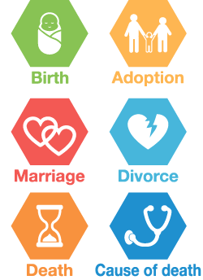

**Global Summit on CRVS**

**– April 2013, Thailand**

Permanent and continuous registration of various vital events of a person’s life.

Production of various appropriate statistics based on CR required for policy making.

**Civil Registration and Vital Statistics (CRVS) is a fundamental administrative function of a government.**

** **

**CR= Civil Registration VS= Vital Statistics**



**Civil registration and vital**

**statistics (CRVS)** is the

continuous, permanent,

compulsory and universal

**recording** of the **occurrence**

and **characteristics** of vital

events of the population

in accordance with the law.

**VS**

**Legal Documents**

**CR**

**CRVS in Global Context**







**Ministerial Conference on CRVS in Asia and the Pacific – November 2014, Thailand**

**Examples of Vital events**



**CRVS in Bangladesh – The Context**

**  **

** **

2014 (August)

CRVS related Steering Committee formed

**CRVS in Bangladesh – A brief history**

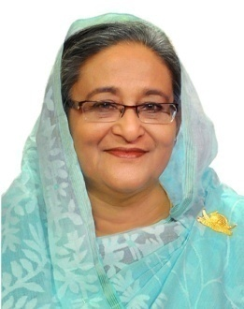 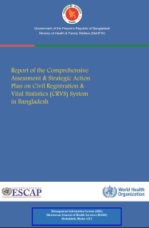 



2013

Comprehensive

Assessment done

2010

Instructed for NPR

Multiple identities, legal complications

Unconnected citizen databases, no uniformity

No identity, invisibility in national statistics

2015 (February)

CRVS Secretariat Established in the Cabinet Division

High TCV and complicated service delivery

Huge national wastage of resources to generate VS

**CRVS in Bangladesh – CRVS + +**

  

**I**ntegrated **S**ervice **D**elivery **P**latform



Integrating all

CR and VS processes

Central

authentication

Convergence of all IDs into Unique ID

**Linking with service delivery**