**National Social Security Strategy (NSSS)**

Leakages, overlapping, under-coverage, duplication, fragmented implementation.

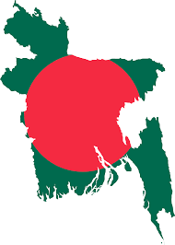

Since the independence ...

Poverty

Strong and consistent political commitments.

143 SSN programmes

23 ministries/divisions

Vulnerability

On average 12.5% of the budget allocation and 2.5% of the GDP every year.

Marginalization

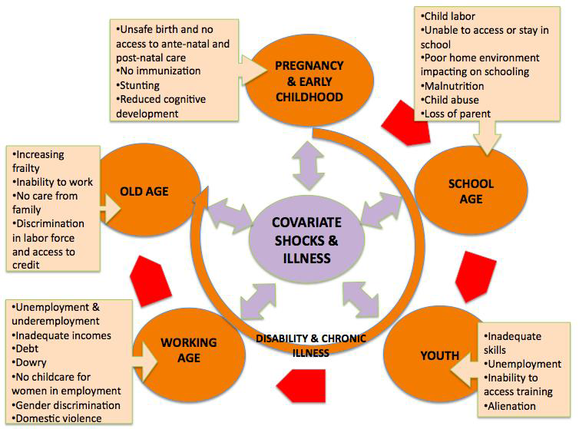

**Vision**

**Inclusive Social Security System**

**Broader human development**

**Increase employment**

**Prevent poverty**

**and inequality**

**Increase**

**economic growth**

**Life Cycle Risks**



**Social allowances**

**MoSW**

MoCA, MoWCA, MoLWA, MoHFW, MoLGRD&C, MoL&E. MoCHTA

**MoPME,**

MoE, MoSW,MoHFW, MoWCA, ICT Div., MoEWOE, MoLE, MoI, MoYS

**HD & Social empowerment**

**Bank & inst. Div.**

Fin. Div., MoH FW, MoL&E

**Social insurance**

Clustering

Implementation

**MoFood,**

MoDMR, MoHFW, MoA, MoWCA, MoF&L, Fin. Div.

**Food security and DA**

**Labour/Livelihood interventions**

**MoDM&R,**

MoLGRD&C, MoWCA, MoSW, MoFin, MoLE, MoF&L

**Livelihood interventions**

**MoDMR,**

MoLGRD&C, MoWCA, MoSW, MoFin, MoL&E, MoF&L

Programme consolidation

Social security for Children

Social security for Working age

Social security for Vulnerable women

Pension for elderly

Social security for disable people

Social security for urban poor

Reformed food security programme

Consolidated special schemes

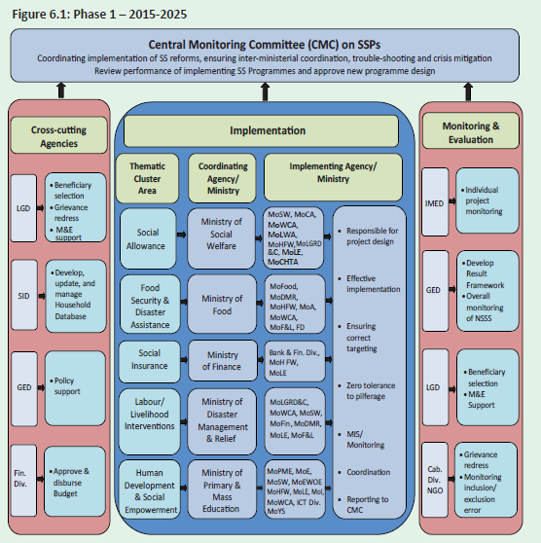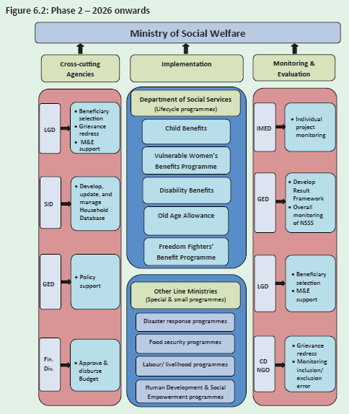

Institutional

Reforms

Strong G2P system

Grievance

redress mechanism

Result-based M&E

Single

registry MIS

reforms

Strong

selection process

2 phased governance reform